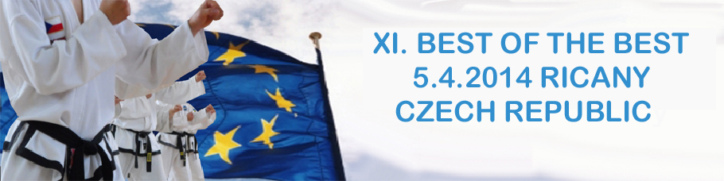

V Říčanech dne 4. března 2014

Dear Instructors, trainers and sportsmen,

It is my pleasure to invite you to international championship Taekwon-Do ITF, known as Best of the Best, in year of 2014. This championship was held for first time in 2000, accompanied by clubs from Czech Republic, Slovenia, Slovakia and Austria. In past years contestants had opportunity to measure their powers against other contestants from Czech republic, Croatia, Bosnia, Slovenia, Slovakia, Austria, Romania, Belarus, Latvia, India and Kosovo in 61 categories
This year will be held in brand new sport centre Na Fialce in city Říčany, April 5, 2014.

We dearly hope this will be the day not only for you but for your apprentices and you will be leaving with more than just a medals and prices, but mostly with great memories.

Looking forward to meeting you all in Říčany
Vladimír Machota 6. Dan
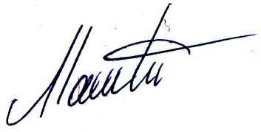
Vice-Chairman of the Organizing

________________________________________________________________________________________
Škola Taekwon-Do Kwang Gae, Tehov–71, 251 01 Říčany Czech Republic, +420 728 408218, +420 606 47 22 72,

